1. Write a Python program to calculate the area of a rectangle given its length and width.

def rect_area(l, w):

    area = l * w

    return area

l = float(input("Enter length:"))

w= float(input("Enter width:"))

area = rect_area(l, w)

print("Area of the rectangle:", area)

Output:

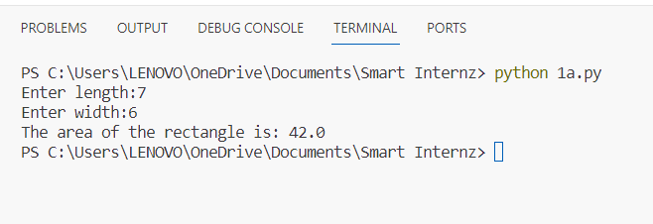

2. Write a program to convert miles to kilometres.

def miles_to_kilometers(miles):

    kilometers = miles * 1.60934

    return kilometers

def main():

    miles = float(input("Distance in miles: "))

    kilometers = miles_to_kilometers(miles)

    print(f"{kilometers} kilometers.")

if __name__ == "__main__":

    main()

Output:

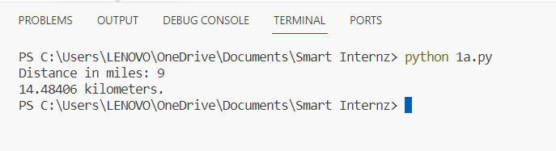

3. Write a function to check if a given string is a palindrome.

def palindrome(s):

    s = s.replace(" ", "").lower()

    return s == s[::-1]

def main():

    test_string = input("Enter string:")

    if palindrome(test_string):

        print("String is palindrome.")

    else:

        print("String is not a palindrome.")

if __name__ == "__main__":

    main()

Output:

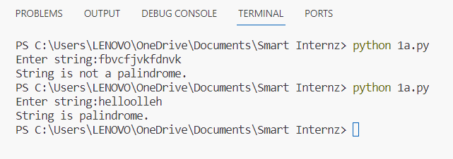

4. Write a Python program to find the second largest element in a list.

def second_large(nums):

    if len(nums) < 2:

        return "List should have at least 2 elements"

    largest = second_largest = float('-inf')

    for num in nums:

        if num > largest:

            second_largest = largest

            largest = num

        elif num > second_largest and num != largest:

            second_largest = num

    return second_largest

def main():

    nums = [int(x) for x in input("Enter elements in the list:").split()]

    second_largest = second_large(nums)

    print(f"Second largest element in the list: {second_largest}")

if __name__ == "__main__":

    main()

Output:

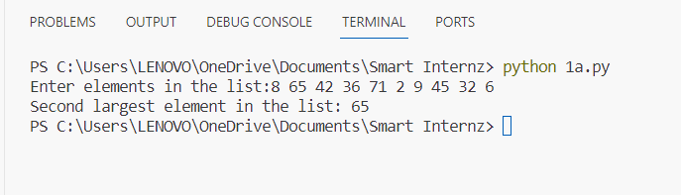

5. Explain what indentation means in Python.

* Indentation refers to the whitespace (spaces or tabs) that is used at the beginning of a line to define the grouping of statements. Indentation is not just for visual formatting; it is a fundamental part of Python's syntax and is used to indicate the structure and nesting of code blocks.

Indentation Rules:

* Python uses four spaces as default indentation spaces. However, the number of spaces can be anything; it is up to the user. But a minimum of one space is needed to indent a statement.
* The first line of Python code cannot have an indentation.
* Indentation is mandatory in Python to define the blocks of statements.
* The number of spaces must be uniform in a block of code.
* It is preferred to use whitespaces instead of tabs to indent in Python. Also, either use whitespace or tabs to indent; intermixing of tabs and whitespaces in indentation can cause wrong indentation errors.

Benefits of Indentation in Python:

* Indentation of code leads to better readability, although the primary reason for indentation in Python is to identify block structures.
* Missing, errors that sometimes pop up in C, and C++ languages can be avoided in Python and also the number of lines of code is reduced.

6. Write a program to perform a set difference operation.

def set_difference(set1, set2):

    return set1.difference(set2)

def main():

    set1 = {4, 5, 6, 7, 8}

    set2 = {1, 2, 3, 4, 5}

    difference = set_difference(set1, set2)

    print("Difference:", difference)

if __name__ == "__main__":

    main()

Output:

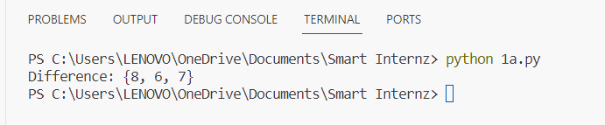

7. Write a Python program to print numbers from 1 to 10 using a while loop.

def print_numbers():

    num = 1

    while num <= 10:

        print(num)

        num += 1

print_numbers()

Output:

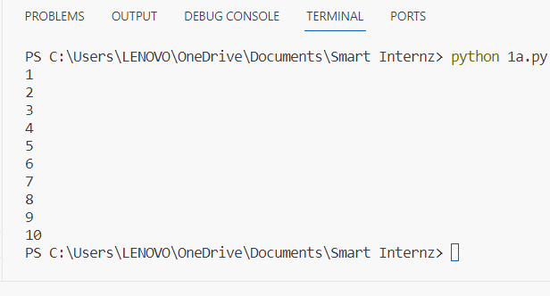

8. Write a program to calculate the factorial of a number using a while loop.

def factorial_num(n):

    factorial = 1

    while n > 1:

        factorial *= n

        n -= 1

    return factorial

def main():

    number = int(input("Enter num:"))

    if number < 0:

        print("Factorial not defined for -ve  nums.")

    else:

        factorial = factorial_num(number)

        print(f"Factorial of {number} is: {factorial}")

if __name__ == "__main__":

    main()

Output:

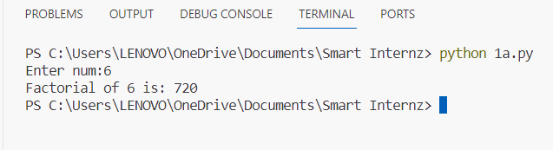

9. Write a Python program to check if a number is positive, negative, or zero using if-elif-else statements.

def check_num(n):

    if n > 0:

        print("Positive.")

    elif n < 0:

        print("Negative.")

    else:

        print("Zero.")

def main():

    number = float(input("Enter number: "))

    check_num(number)

if __name__ == "__main__":

    main()

Output: 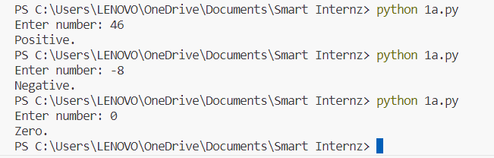

10. Write a program to determine the largest among three numbers using conditional statements.

def largest_num(n1, n2, n3):

    if n1 >= n2 and n1 >= n3:

        largest = n1

    elif n2 >= n1 and n2 >= n3:

        largest = n2

    else:

        largest = n3

    return largest

def main():

    n1 = float(input("Enter num1: "))

    n2 = float(input("Enter num2: "))

    n3 = float(input("Enter num3: "))

    largest = largest_num(n1, n2, n3)

    print(f"Largest among {n1}, {n2}, {n3} is: {largest}")

if __name__ == "__main__":

    main()

Output:

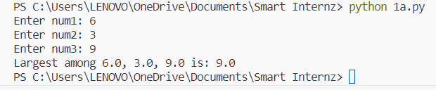

11. Write a Python program to create a numpy array filled with ones of the given shape.

import numpy as np

def create_ones_array(shape):

    return np.ones(shape)

def main():

    shape = tuple(map(int, input("Enter the shape of the array: ").split()))

    ones_array = create_ones_array(shape)

    print("Array of ones:")

    print(ones_array)

if __name__ == "__main__":

    main()

Output:

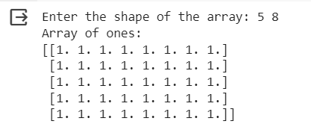

12. Write a program to create a 2D numpy array initialized with random integers.

import numpy as np

def array(rows, cols):

    return np.random.randint(low=0, high=100, size=(rows, cols))

def main():

    rows = int(input("Enter no.of rows:"))

    cols = int(input("Enter no.of columns:"))

    random_array = array(rows, cols)

    print("Random 2D array:")

    print(random_array)

if __name__ == "__main__":

    main()

Output:

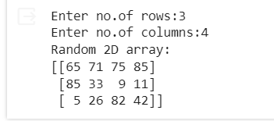

13. Write a Python program to generate an array of evenly spaced numbers over a specified range using linspace.

import numpy as np

def linspace(start, stop, num):

    return np.linspace(start, stop, num)

def main():

    start = float(input("Enter start value:"))

    stop = float(input("Enter stop value:"))

    num = int(input("Enter no.of values:"))

    linspace_array = linspace(start, stop, num)

    print("Final Array:")

    print(linspace_array)

if __name__ == "__main__":

    main()

Output:

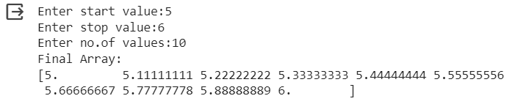

14. Write a program to generate an array of 10 equally spaced values between 1 and 100 using linspace.

import numpy as np

def array():

    return np.linspace(1, 100, 10)

def main():

    final_array = array()

    print("Final Array:")

    print(final_array)

if __name__ == "__main__":

    main()

Output:

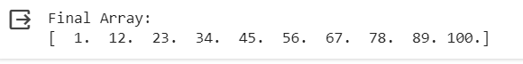

15. Write a Python program to create an array containing even numbers from 2 to 20 using arange.

import numpy as np

def array():

    return np.arange(2, 21, 2)

def main():

    even_array = array()

    print("Final Array:")

    print(even_array)

if __name__ == "__main__":

    main()

Output:



16. Write a program to create an array containing numbers from 1 to 10 with a step size of 0.5 using arange.

import numpy as np

def create_array():

    return np.arange(1, 10.5, 0.5)

def main():

    n_array = create_array()

    print("Final Array:")

    print(n_array)

if __name__ == "__main__":

    main()

Output:

